CPS470: Computer Networks and Security

Written Homework 5
Total Points: 100

Note: In all written assignments, please show as much of your work as you can. Even if you get a wrong answer, you can get partial credit if you show your work. If you make a mistake, it will also help the grader show you where you made a mistake. You can either type your answers in the solution area and submit the file directly on Isidore or hand-write your answers and get a scanned version of it to submit on Isidore. If you find the default space is not sufficient for you to type/handwrite your answers, please feel free to enlarge the space as needed. Please make sure your handwriting is clear and understandable. If the grader or I cannot understand your handwriting, you get zero for your solutions.

Problem 1: Dijkstra’s Link State Routing. Consider the 6-node network shown below, with the given link costs. Using Dijkstra's algorithm, find the least cost path from source node u to all other destinations. Show your work in tabular format, as in the network control plane slides.
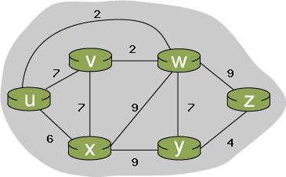

Solution:

Problem 2: Distance Vector Routing.

Consider the network fragment shown below. x has only two attached neighbors, w and y . w has a minimum-cost path to destination u (not shown) of 5, and y has a minimum-cost path to u of 6. The complete paths from w and y to u (and between w and y ) are not shown. All link costs in the network have strictly positive integer values.
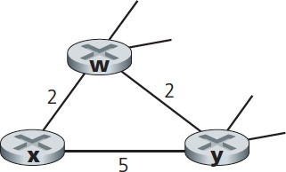

- Give x ’s distance vector for destinations w, y, and u .
- Give a link-cost change for either c (x,w ) or c (x,y ) such that x will inform its neighbors of a new minimum-cost path to u as a result of executing the distance-vector algorithm.
- Give a link-cost change for either c (x,w ) or c (x,y ) such that x will not inform its neighbors of a new minimum-cost path to u as a result of executing the distance-vector algorithm.

Solution:

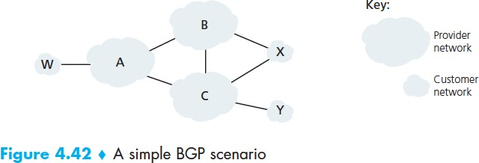
Problem 3: BGP and path advertisement.

Figure 4.42 is shown to the right.

Consider the path information that reaches stub networks W,
X, and Y. Based on the information available at W and X, what are their respective views of the network topology? [Hint: you need to think about
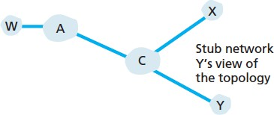
which networks pass on which path information to neighboring networks]. Justify your answer. The topology view at Y is shown to the right (lower), so you really only need to answer this question for W and X.

Solution:

